Contents

Introduction 2

Design authentication 3

Design authorization 4

Design governance 4

Design security for applications 4

# Introduction

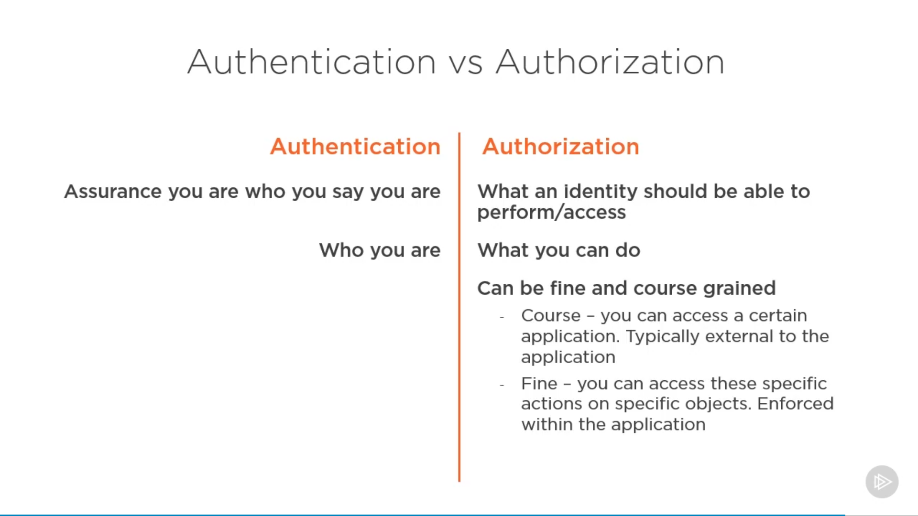

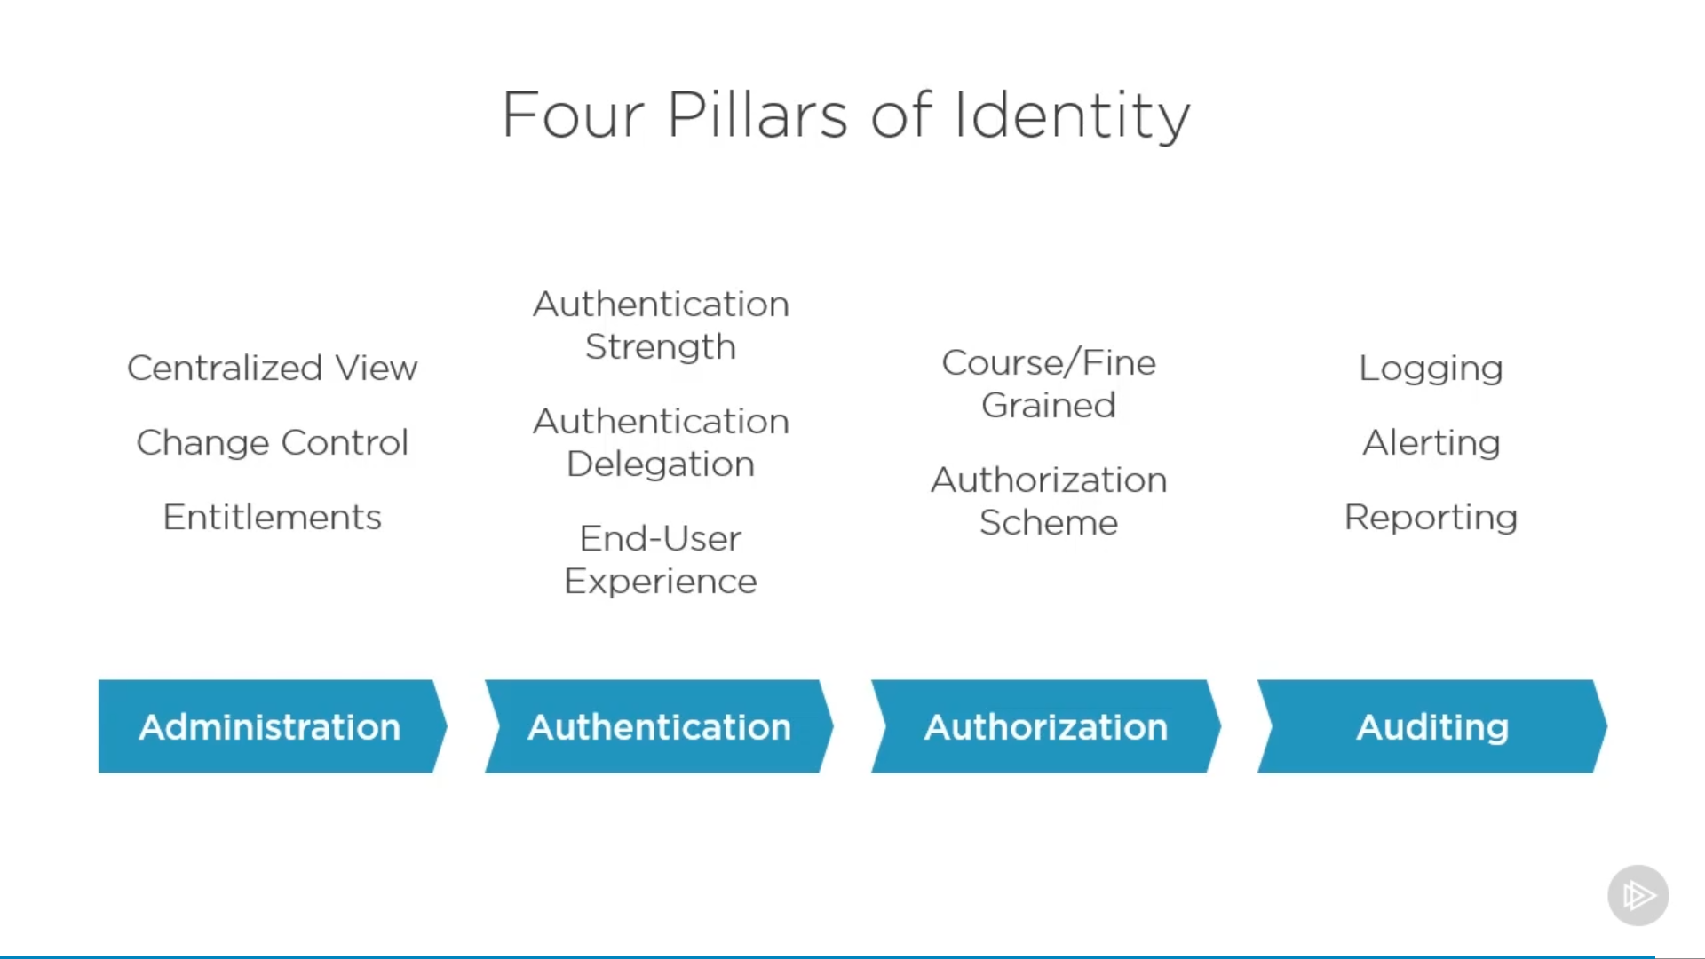

<https://social.technet.microsoft.com/wiki/contents/articles/15530.the-four-pillars-of-identity-identity-management-in-the-age-of-hybrid-it.aspx>

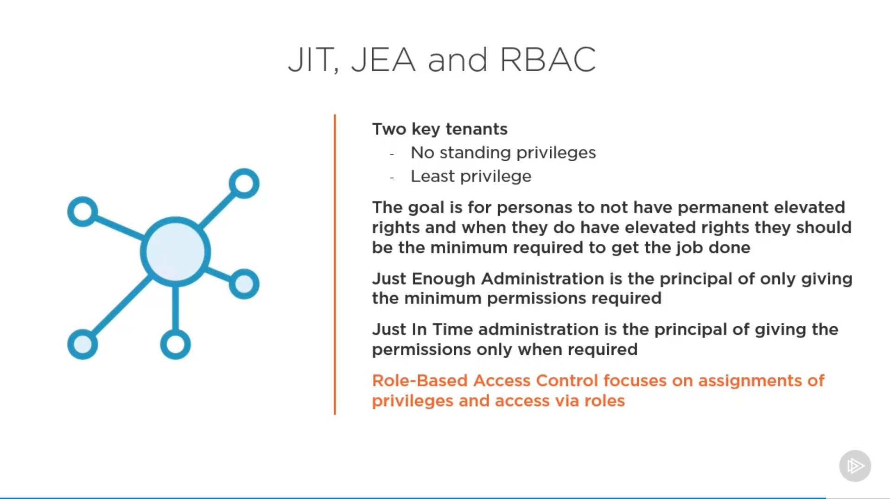

# Azure AD Overview

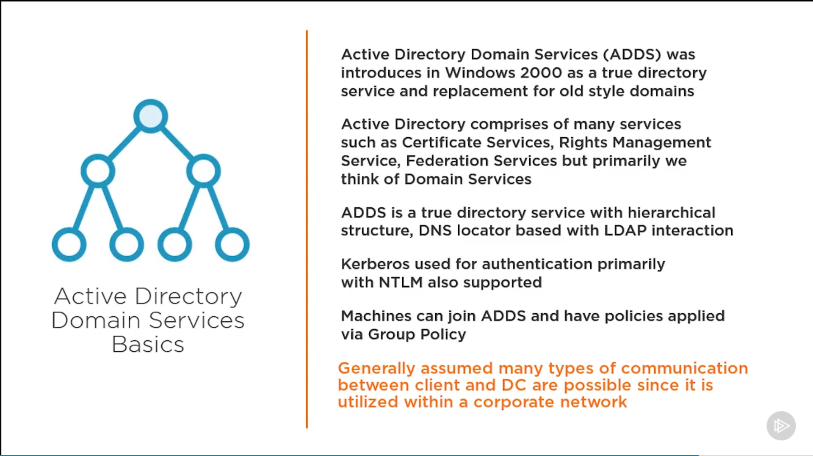

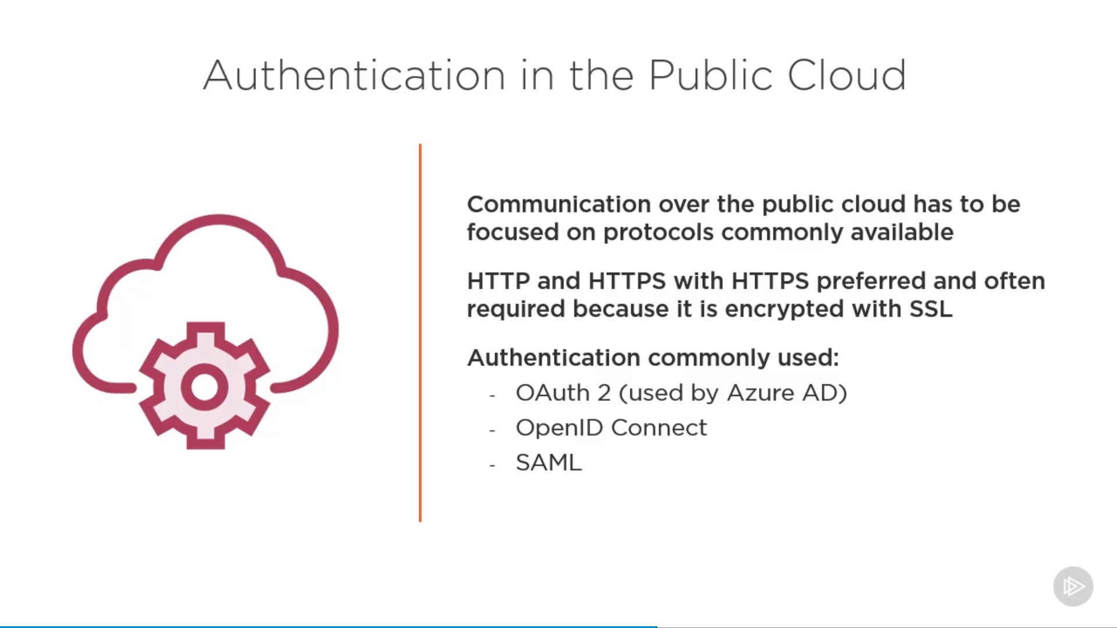

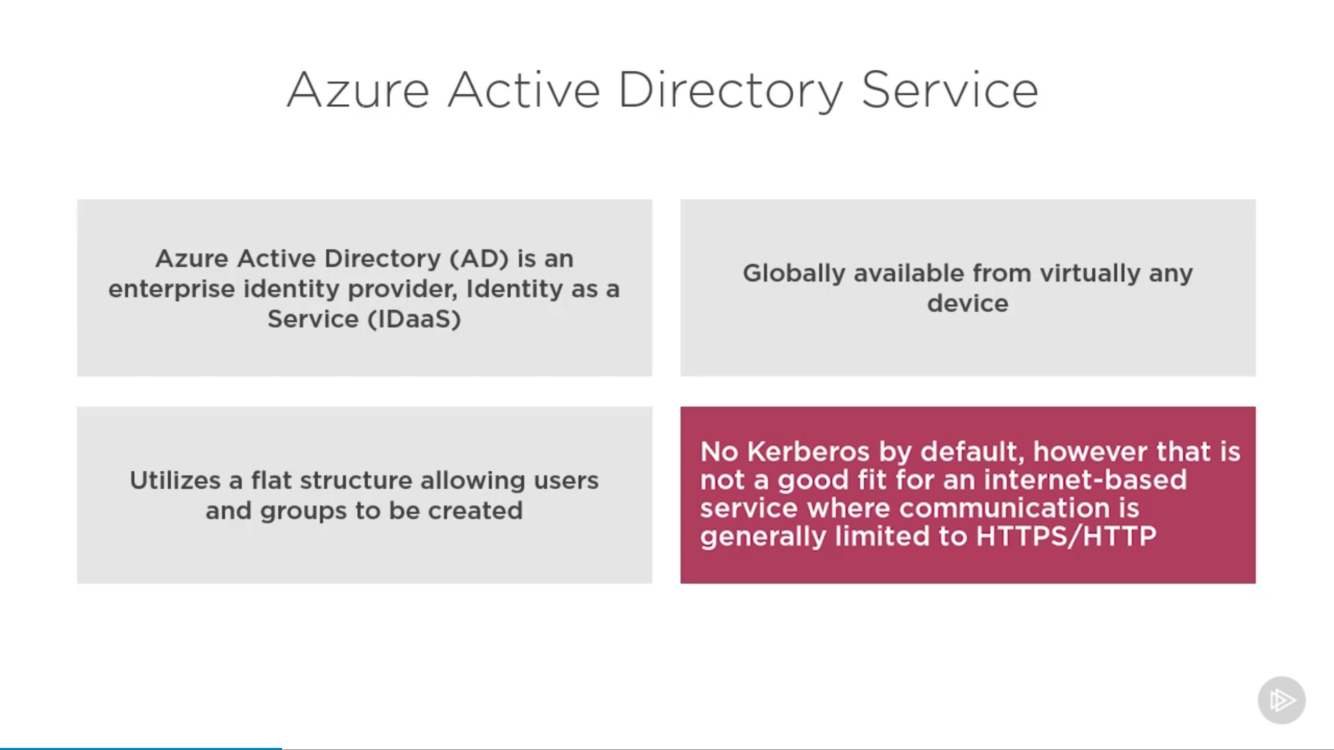

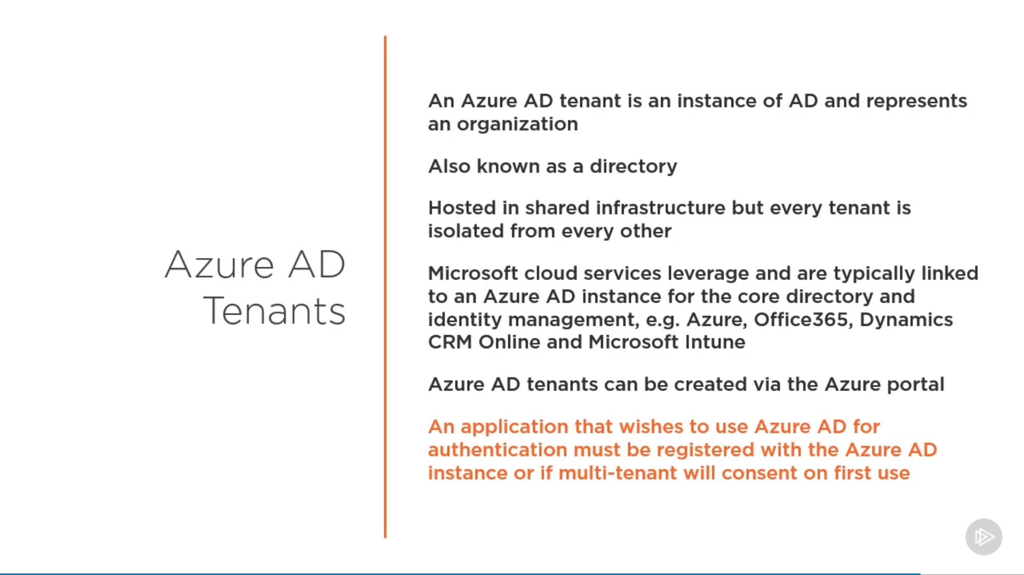

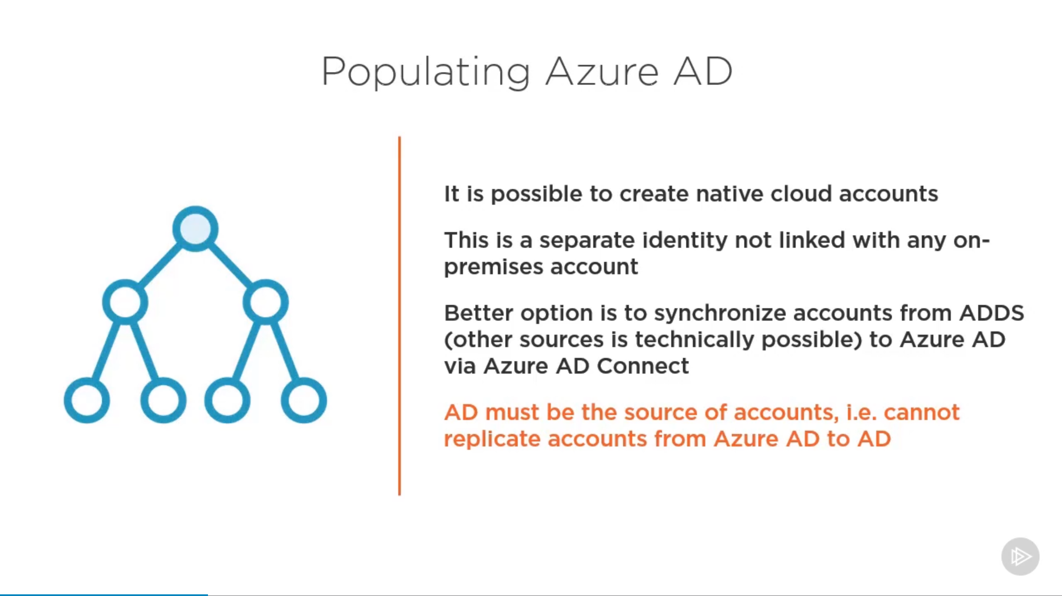

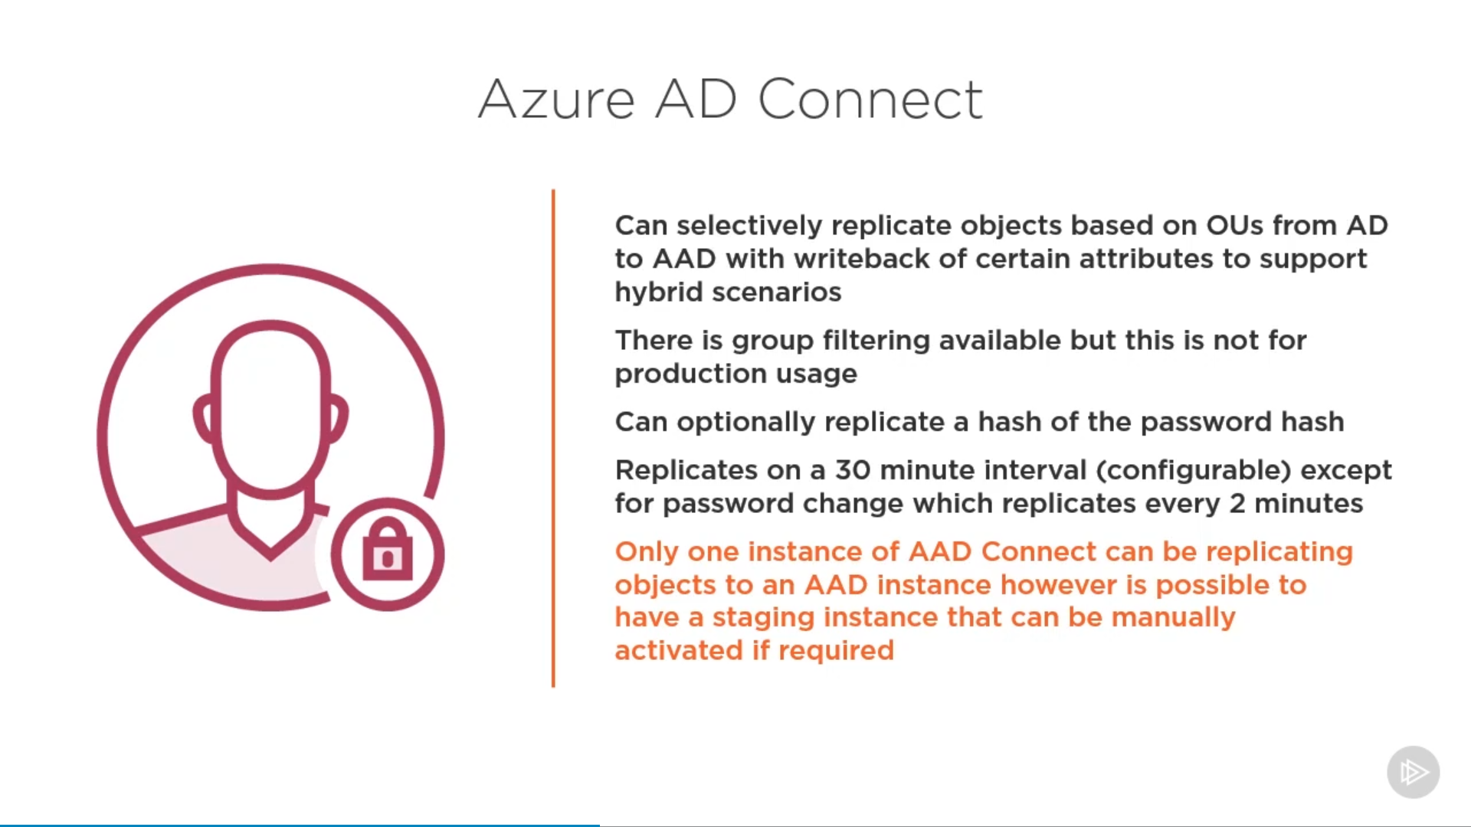

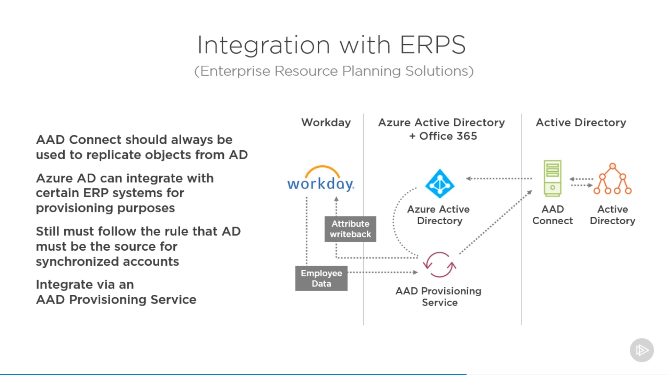

# Design authentication

* recommend a solution for single-sign on
* recommend a solution for authentication
* recommend a solution for Conditional Access, including multi-factor authentication
* recommend a solution for network access authentication
* recommend a solution for a hybrid identity including Azure AD Connect and Azure AD Connect Health
* recommend a solution for user self-service
* recommend and implement a solution for B2B integration

**Azure AD playlist**:

<https://www.youtube.com/playlist?list=PL-V4YVm6AmwUFpC3rXr2i2piRQ708q_ia>

## Azure AD Domain Services

<https://docs.microsoft.com/en-us/azure/active-directory-domain-services/overview>

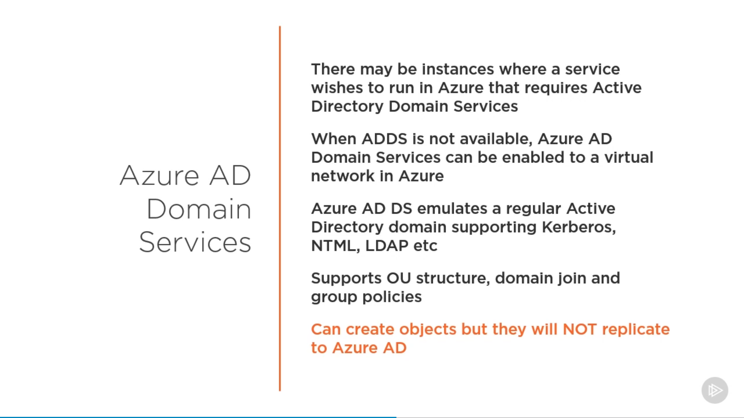

## Azure AD Connect

### Topologies for Azure AD Connect

<https://docs.microsoft.com/en-us/azure/active-directory/hybrid/plan-connect-topologies>

## Azure B2B

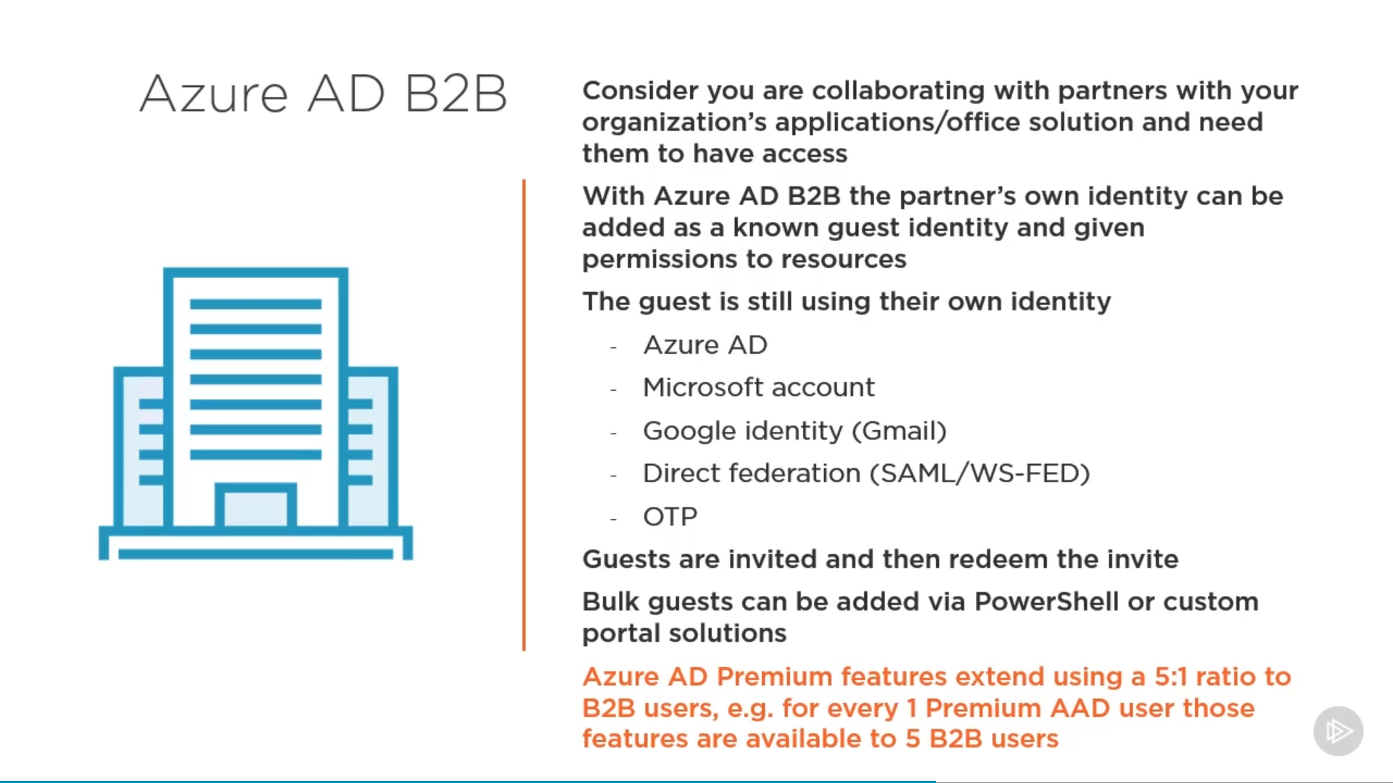

## Azure B2C

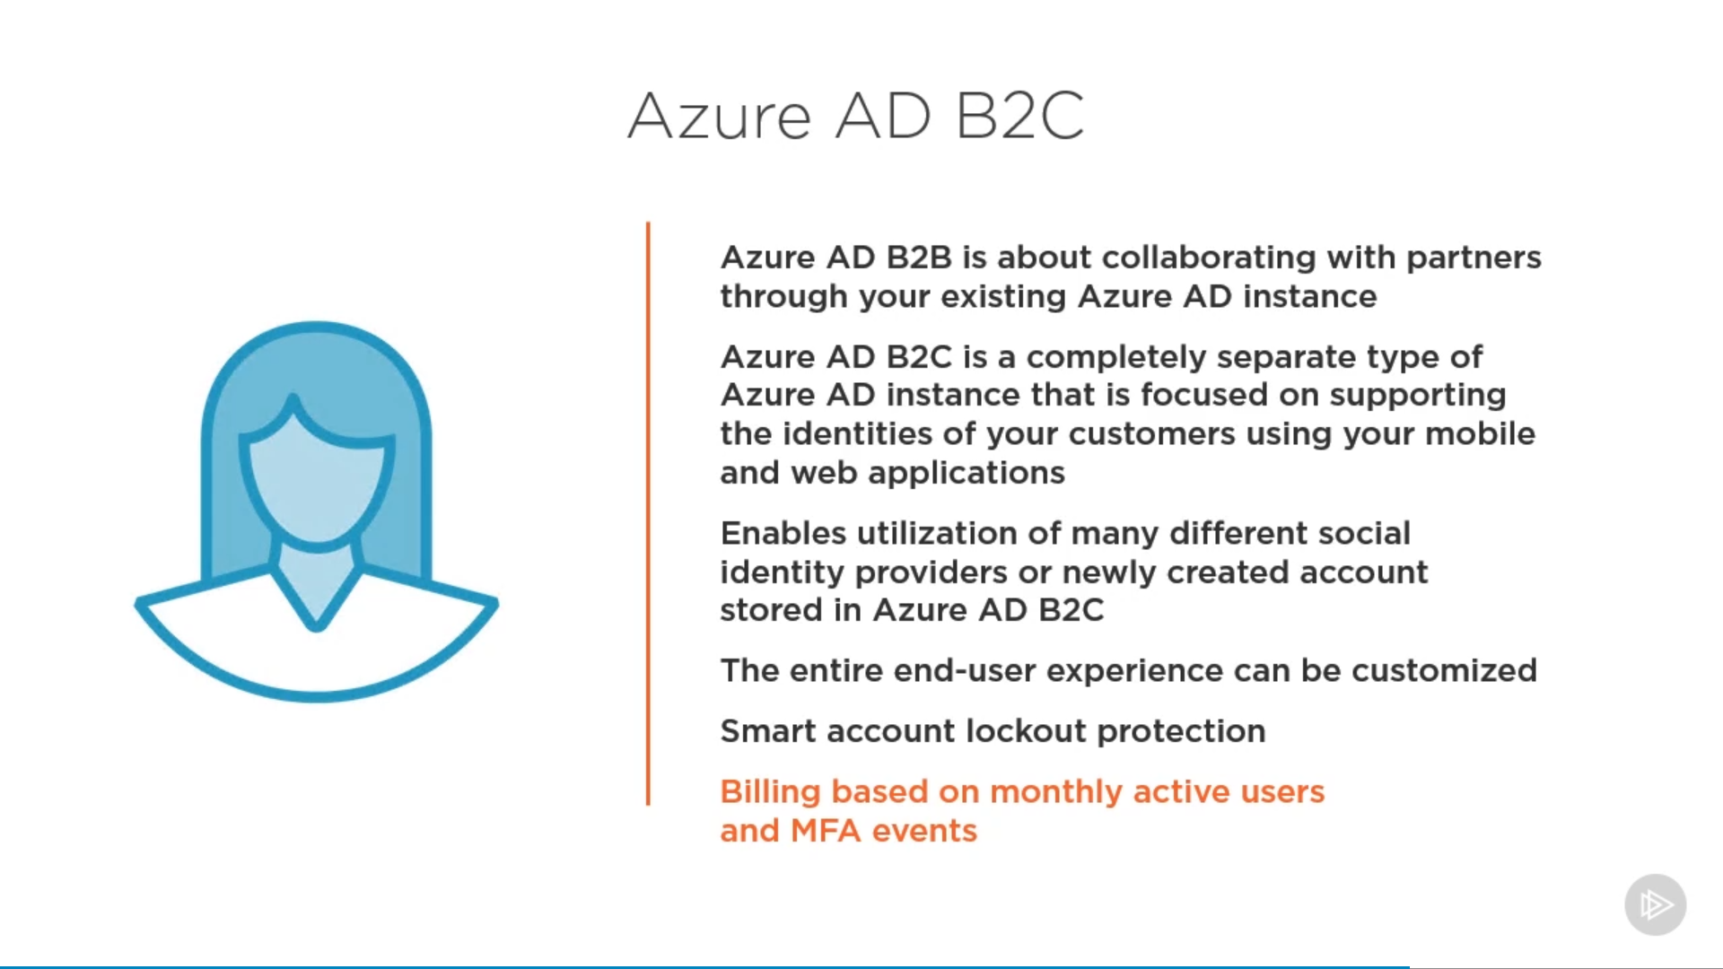

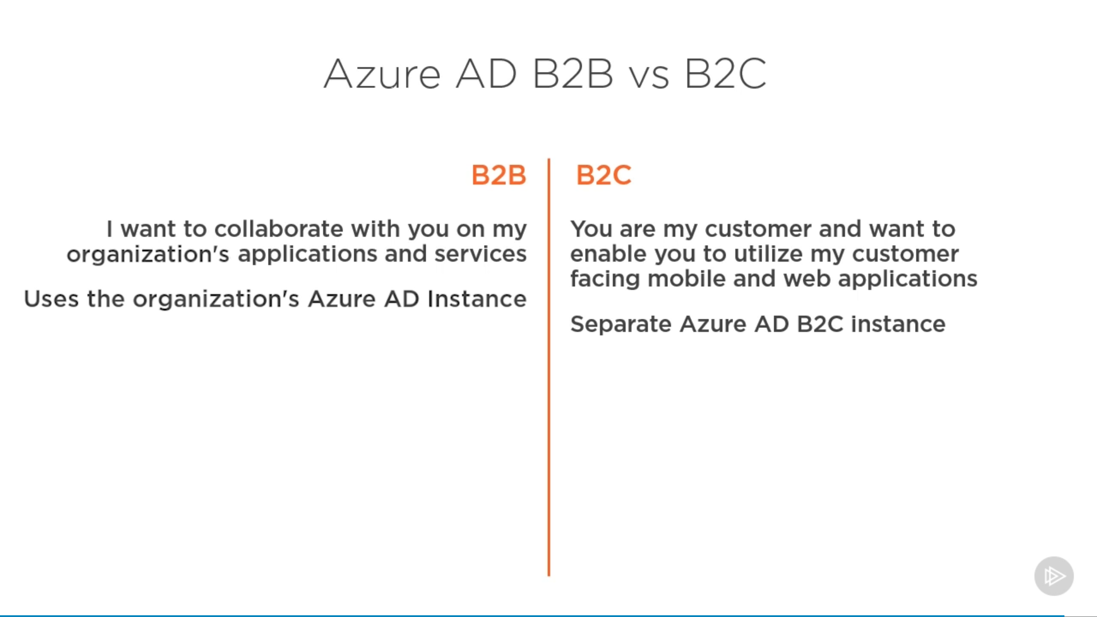

# Design authorization

* choose an authorization approach
* recommend a hierarchical structure that includes management groups, subscriptions and resource groups
* recommend an access management solution including RBAC policies, access reviews, role assignments, physical access, Privileged Identity Management (PIM), Azure AD Identity Protection, Just In Time (JIT) access

## AD Groups

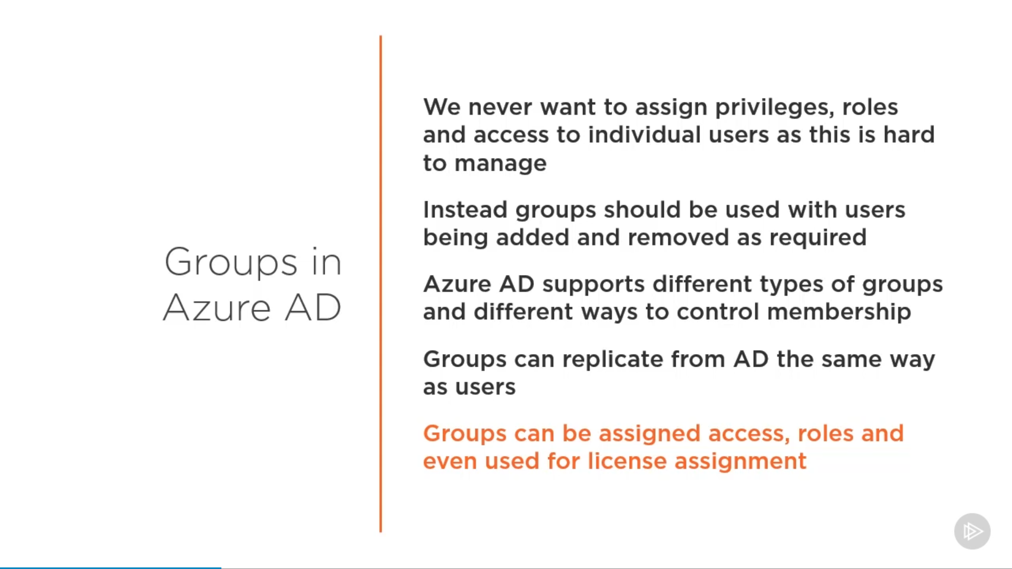

### Group Types

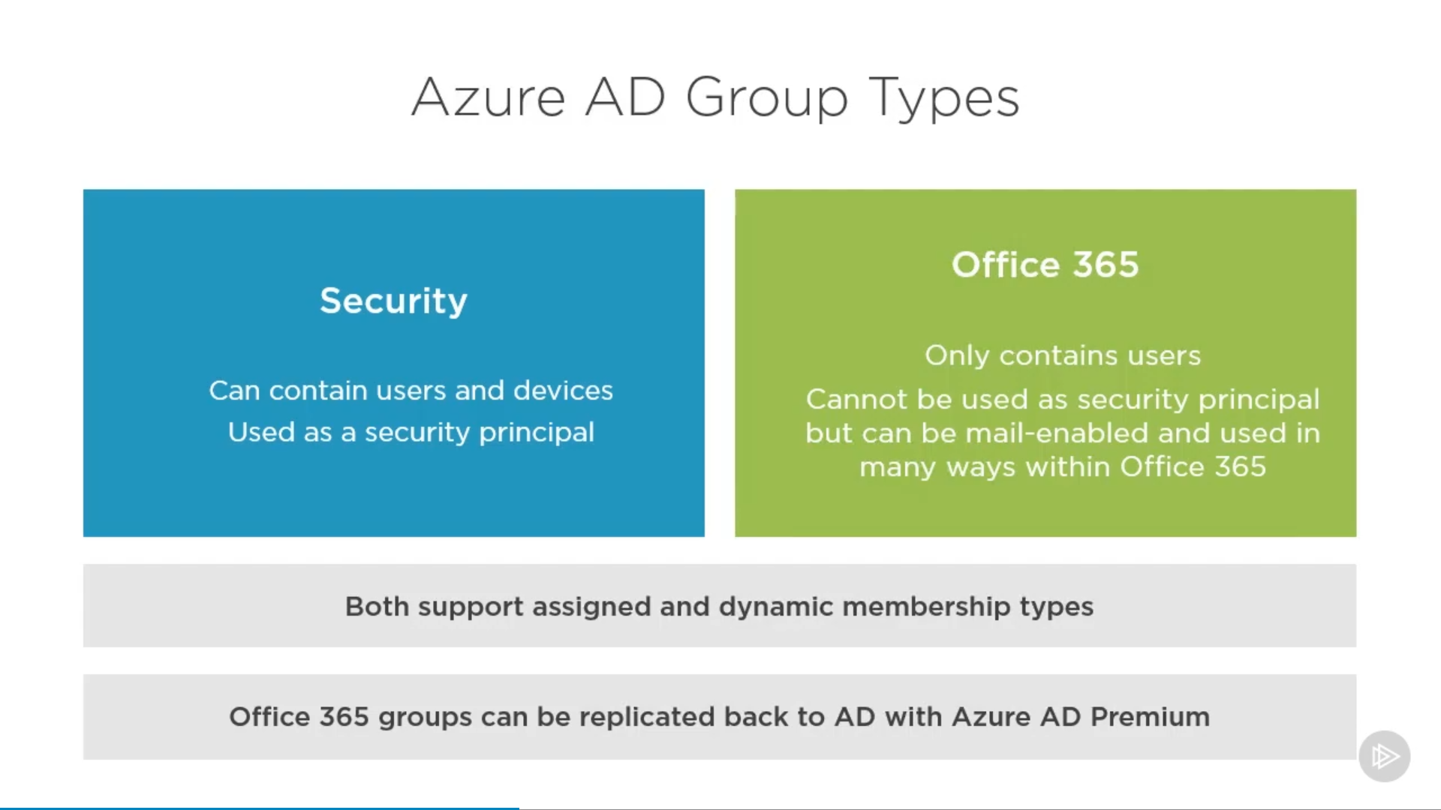

### Membership Type

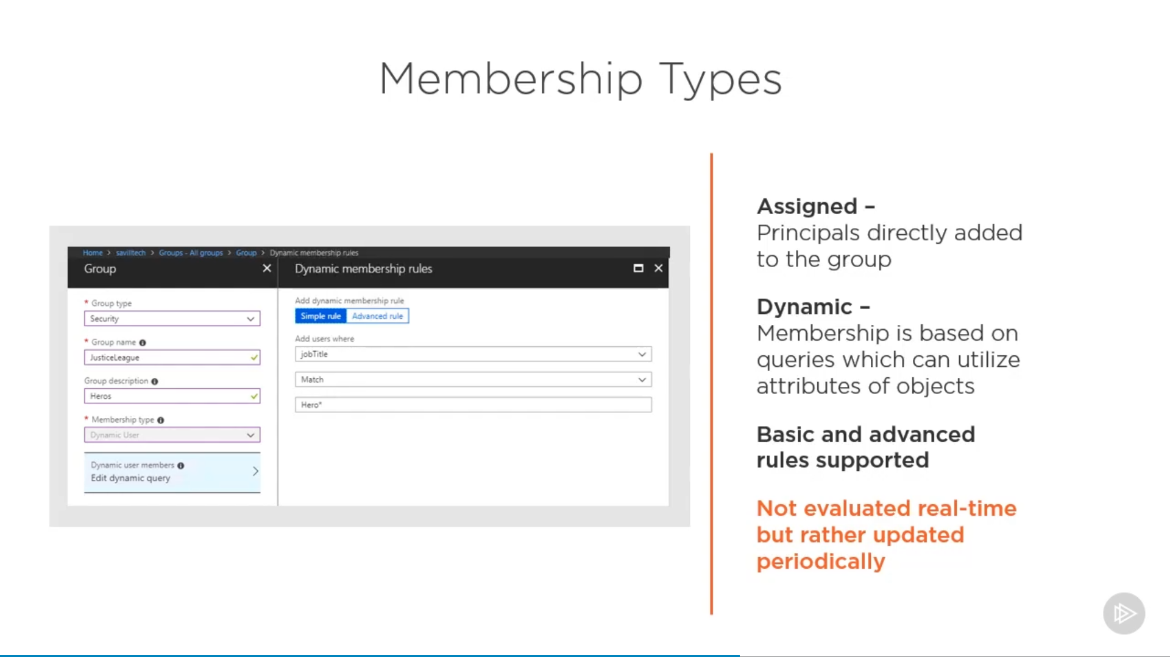

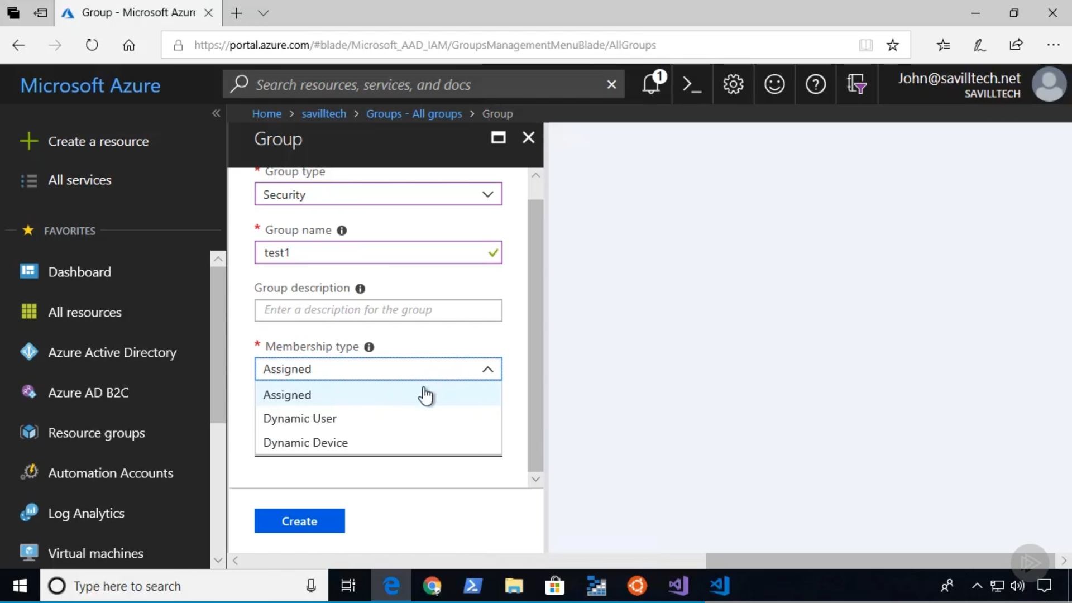

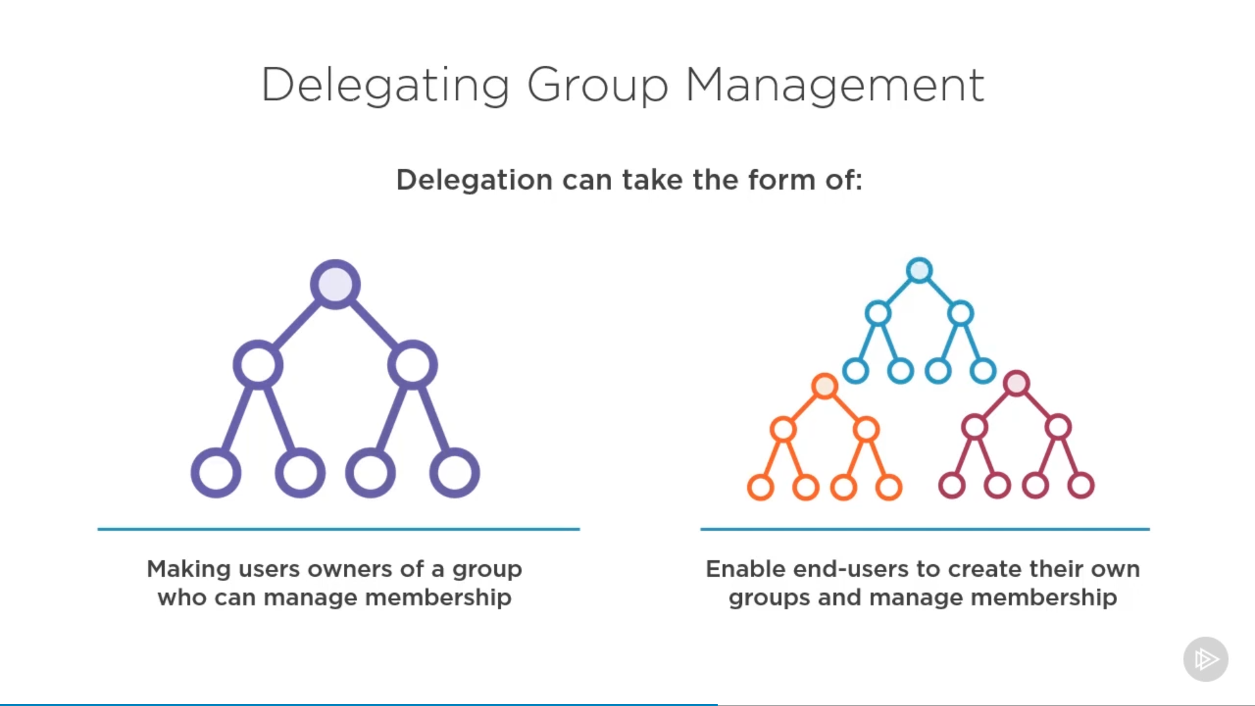

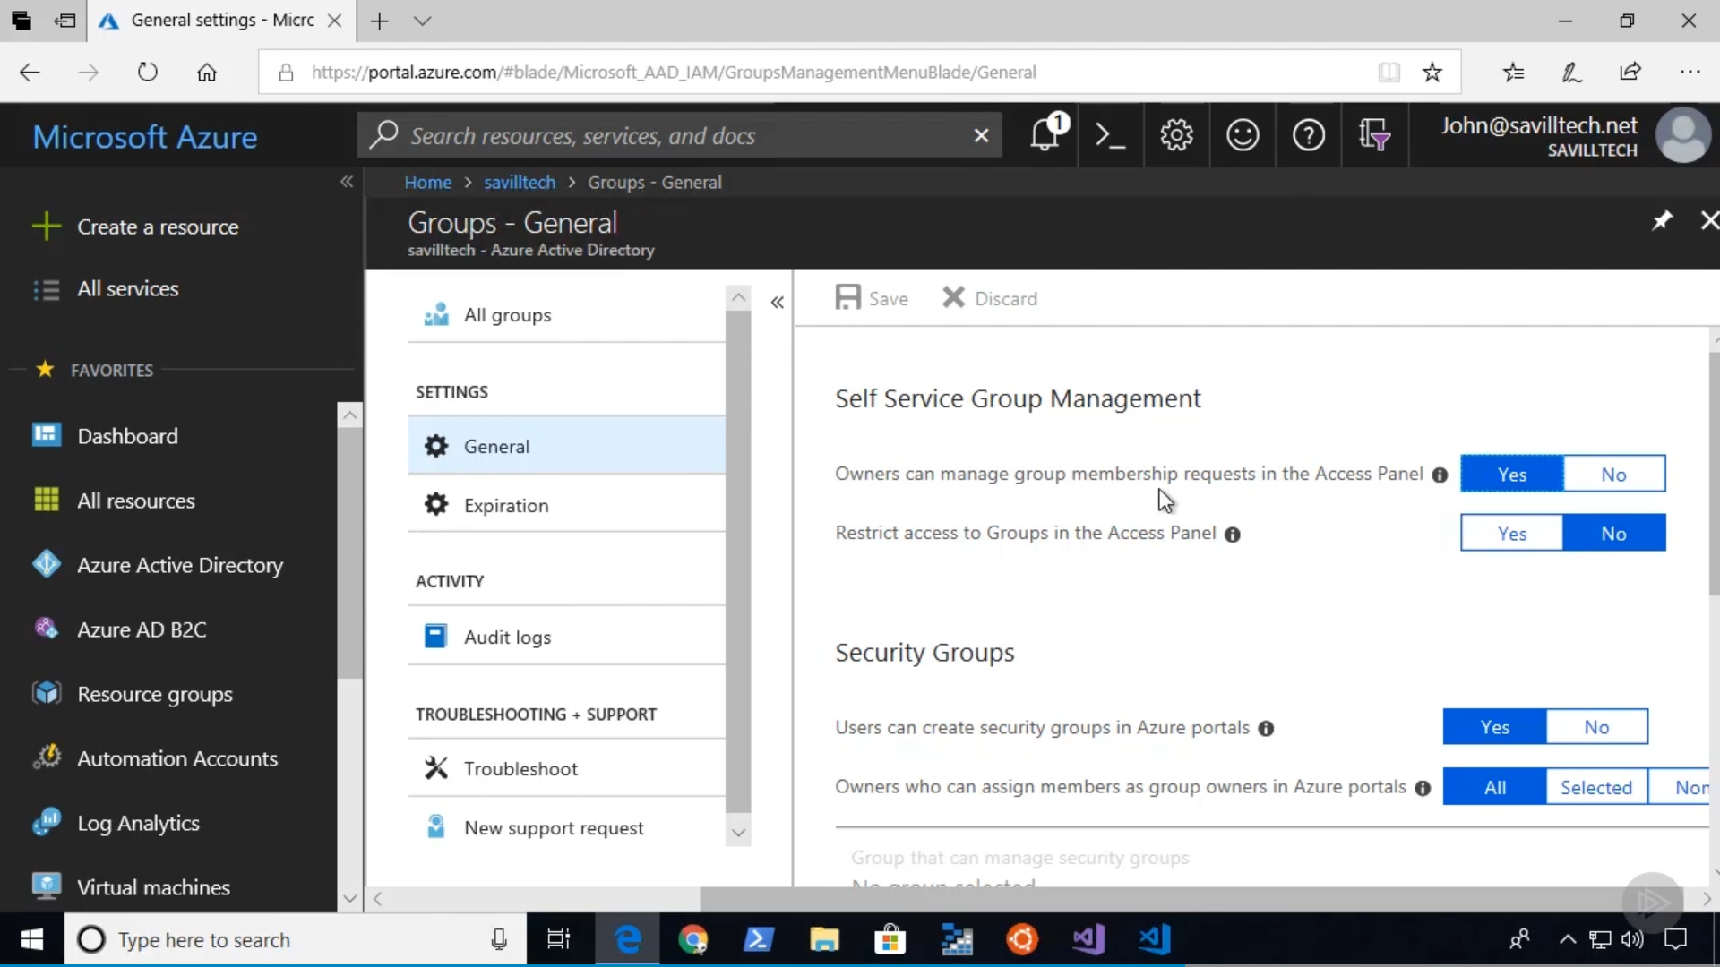

# Design governance

* recommend a strategy for tagging
* recommend a solution for using Azure Policy
* recommend a solution for using Azure Blueprint

# Design security for applications

* recommend a solution that includes KeyVault o What can be stored in KeyVault o KeyVault operations o KeyVault regions
* recommend a solution that includes Azure AD Managed Identities
* recommend a solution for integrating applications into Azure AD